 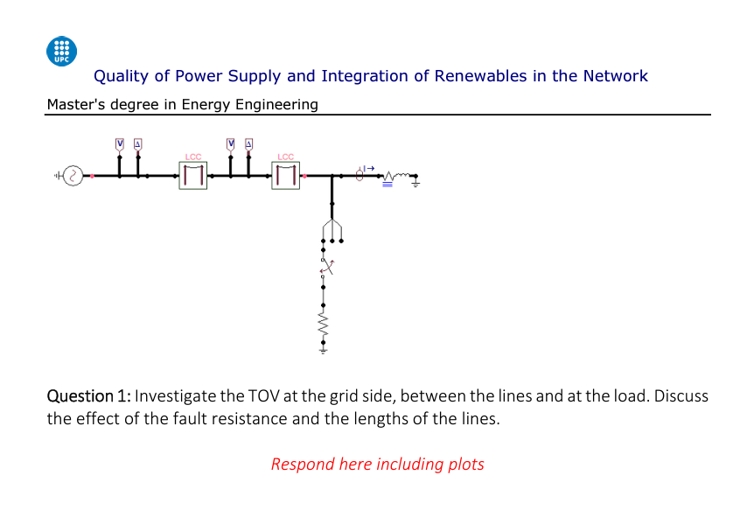

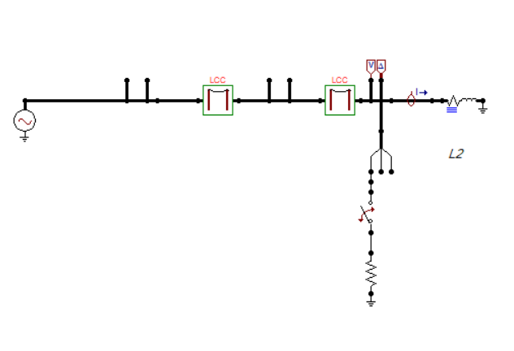

Figure , my ATP simulation, we are introducing the “fault to ground” in the phase C at the load side.  
Simulated Lines are 10+10=20Km long.

Single-phase faults to ground could be originated by breakdowns in insulations (e.g. degradation, pollution, triggered by lightning, vegetation… )

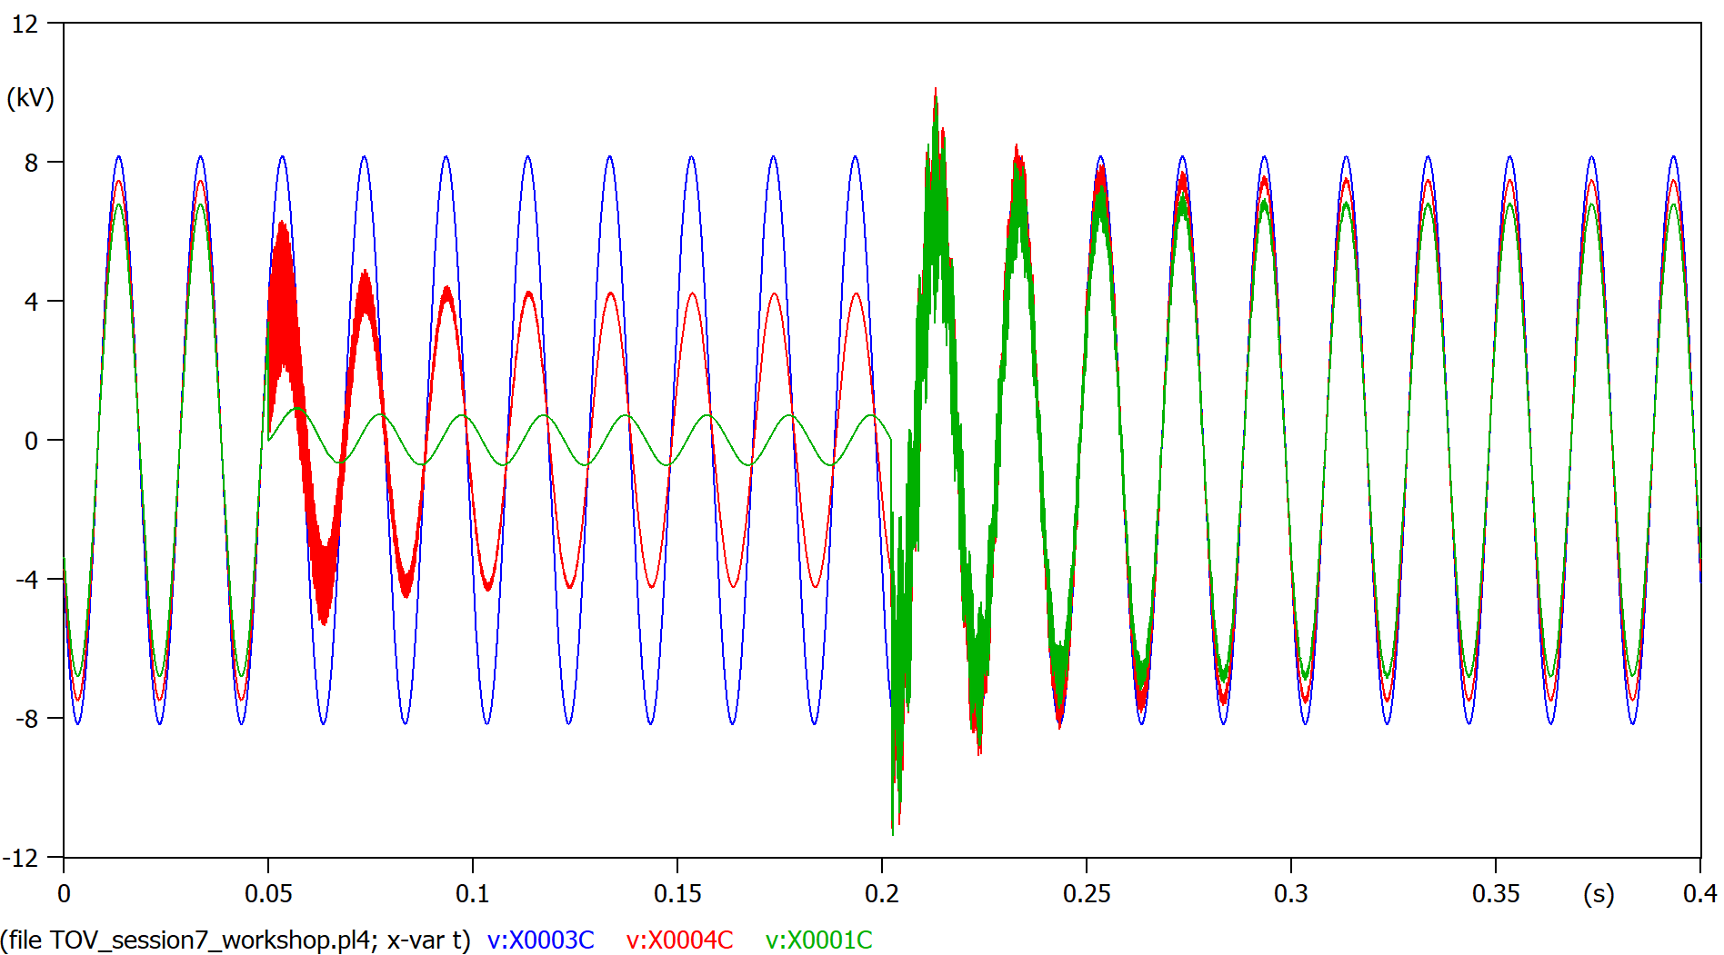

Figure , voltage in the phase C, different points: at the grid side (blue), between lines (red), at the load side (green)   
20Km transmission line

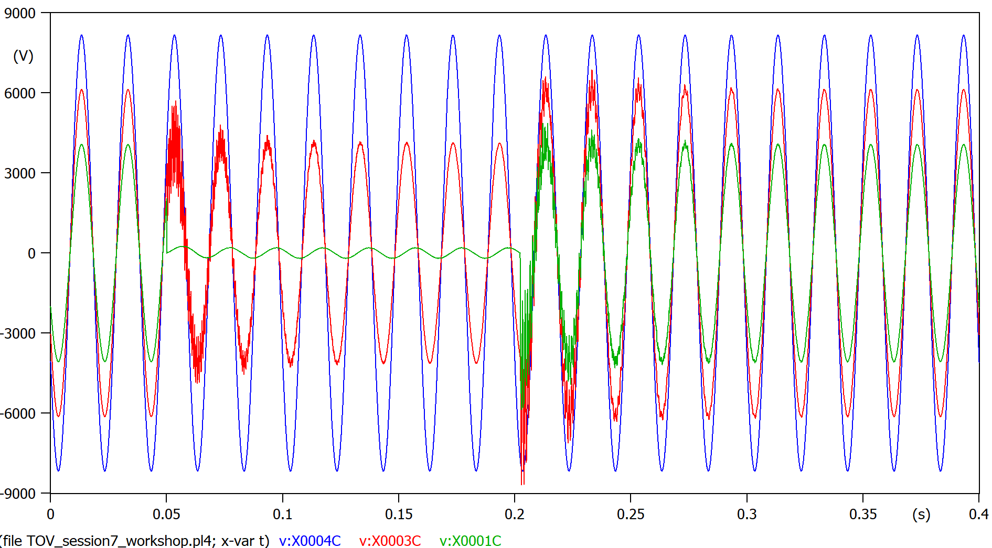

Figure 3, voltage in the phase C, different points: at the grid side (blue), between lines (red), at the load side (green)   
100Km transmission line

We are simulating a fault to ground happening at the the load side, the voltage seen by the load in the faulted phase C (Figure 2, green plot) shows a huge dip caused by the ground leaking all the power the grid+transmission line is able to provide. This voltage dip is propagated trough the transmission line (Figure 2, red plot) but once is reaches the end of transmission line there is no visible disturbance in voltage due to good grounding (Figure 2, blue plot).

Once the TOV is cleared at 0.2 seconds, after 0.05 seconds of voltage ringing (peaked at 110%, load side) the system goes back to steady state. The same figure (Figure 3, green plot) with a 100Km transmission line shows a shorter transitory time as expected in Equation 1.

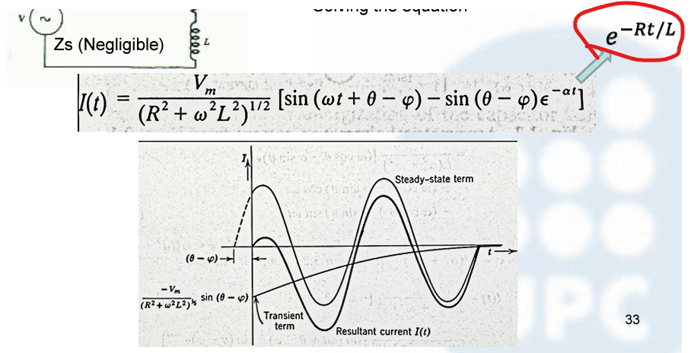

Equation 1, exponential decay of transient current noise of TOVs

As seen by B, one of the “healthy” phases, the only voltage disturbances are the ringing noise from the TOV happening (0.05s) and clearing (0.2). (Figure 4)

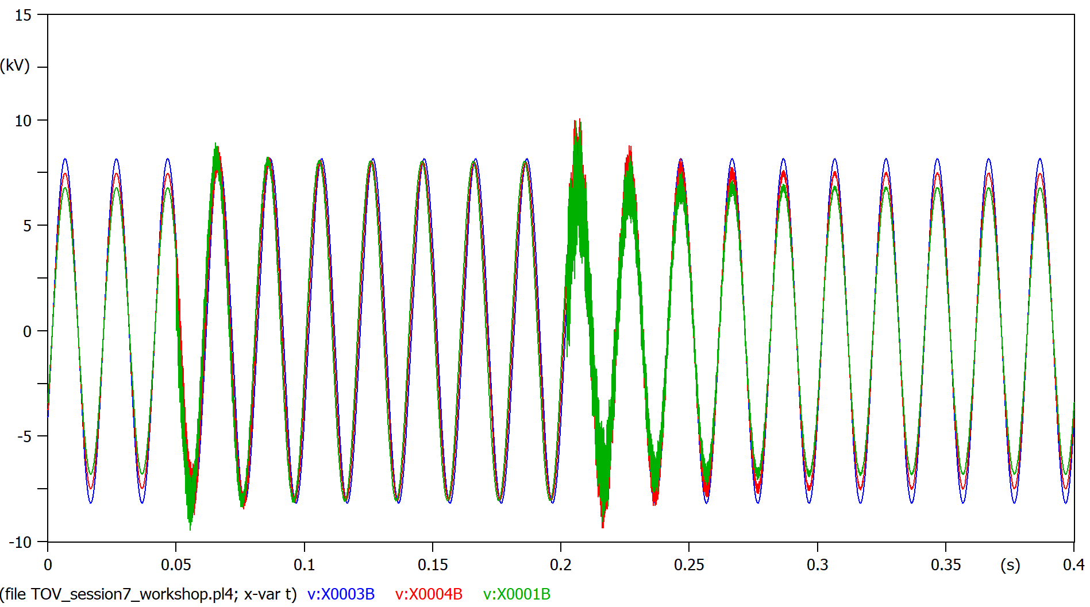

Figure , voltage in the “healthy” phase B, different points: at the grid side (blue), between lines (red), at the load side (green)

Our grid is solidly grounded, this translates into no overvoltage shown in any of the phases at the grid side when the TOV happens. (Figure 5)

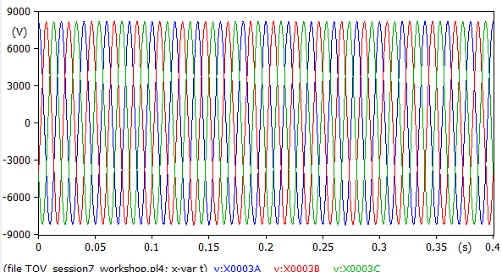

Figure 5,voltage at the grid side

By looking at the current demanded from the grid (Figure 6) by our faulted system, we detect a huge surge in C phase current demand.

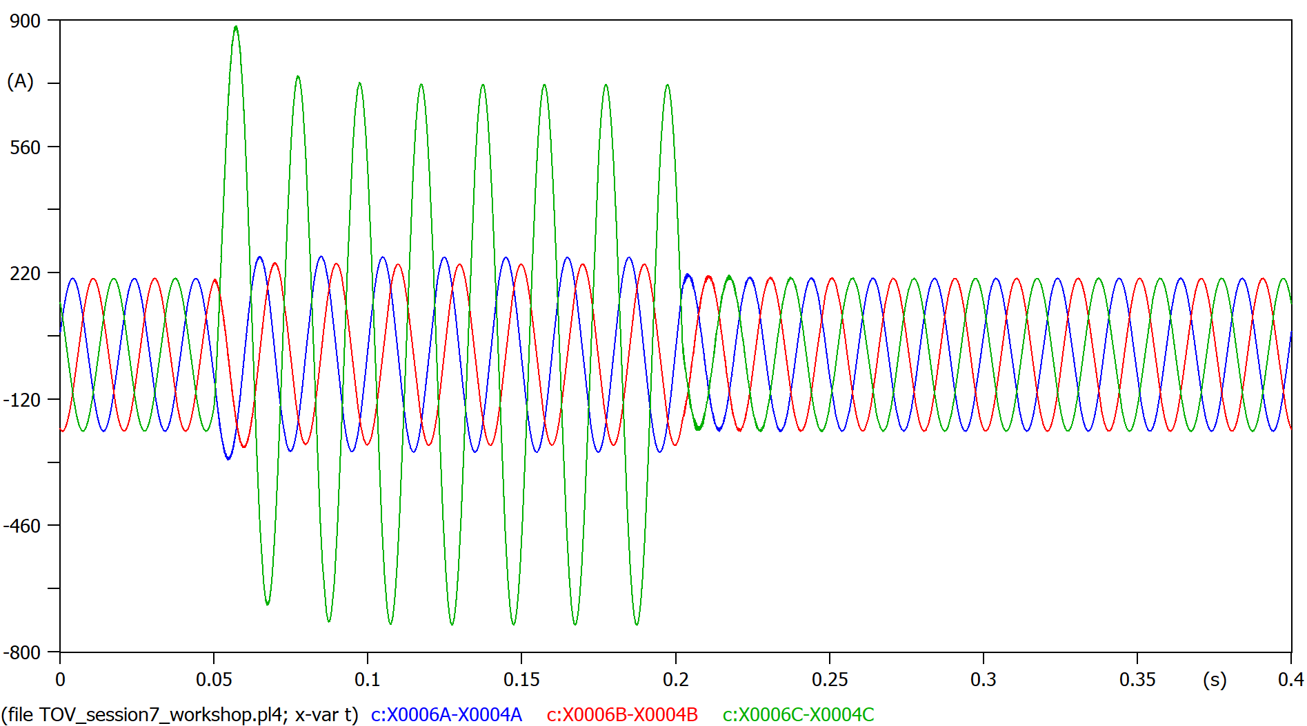

Figure 6,current supplied from the grid side to the system

That current in phase C is “eaten” by out grounded induced fault, the load “sees” very low current in comparison (Figure 6, green plot).

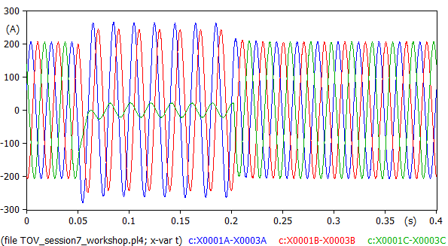

Figure 7,current going into the load

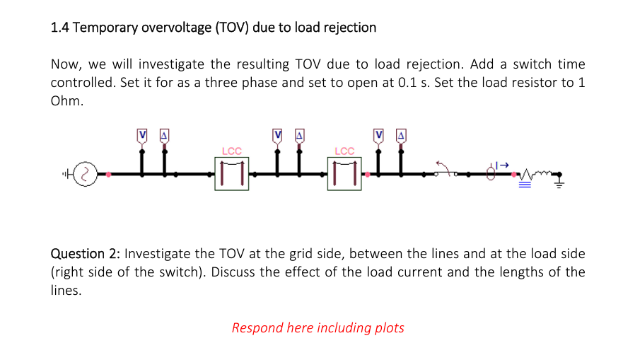

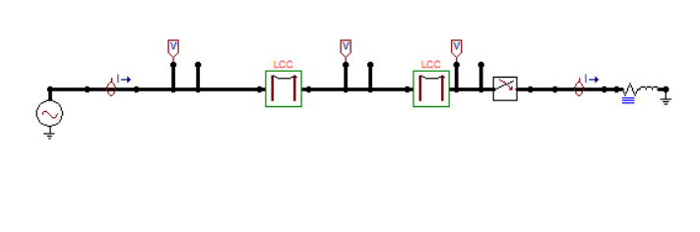

Figure 8, my ATP model

This is a symmetrical TOV, affects all three phases equally that’s why I’m only one phase represents the system’s behavior. As expected from this kind of faults, the voltage up to the TOV switch rises and it will take a long time to drop down to normal. (Figure 9).

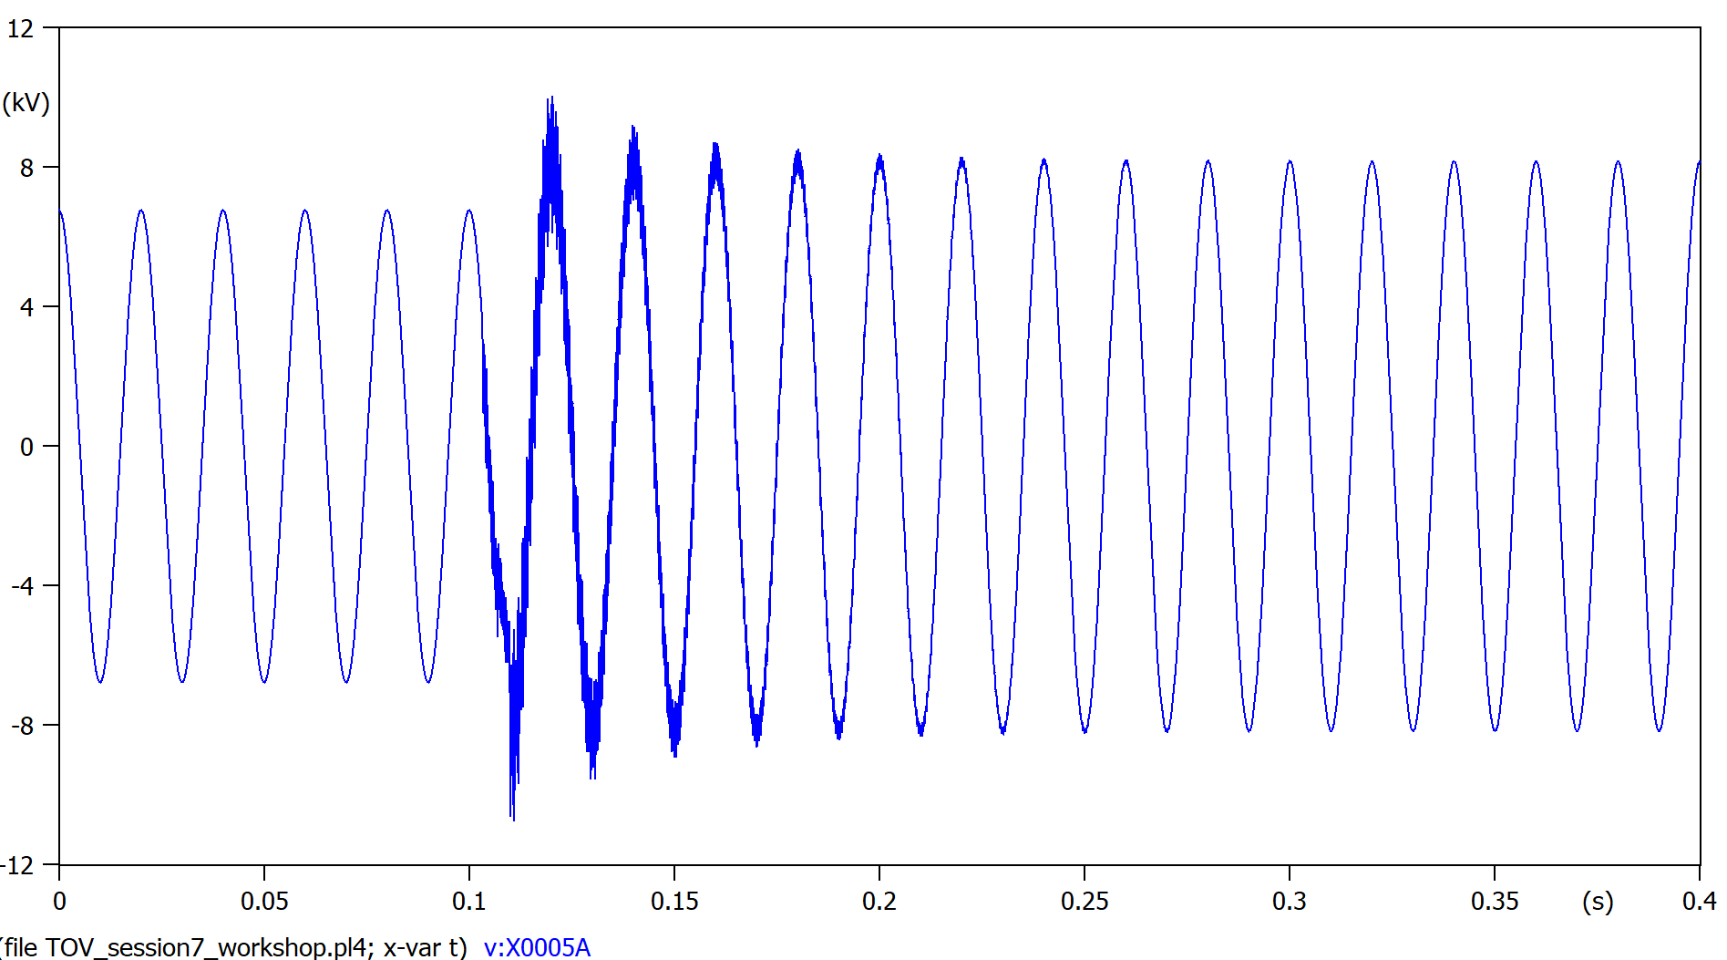

Figure 9, voltage of phase A in between transmission line and TOV switch.  
Lines are 10+10=20Km long

The same system with 5x longer transmission lines shows a higher overvoltage. (Figure 10)

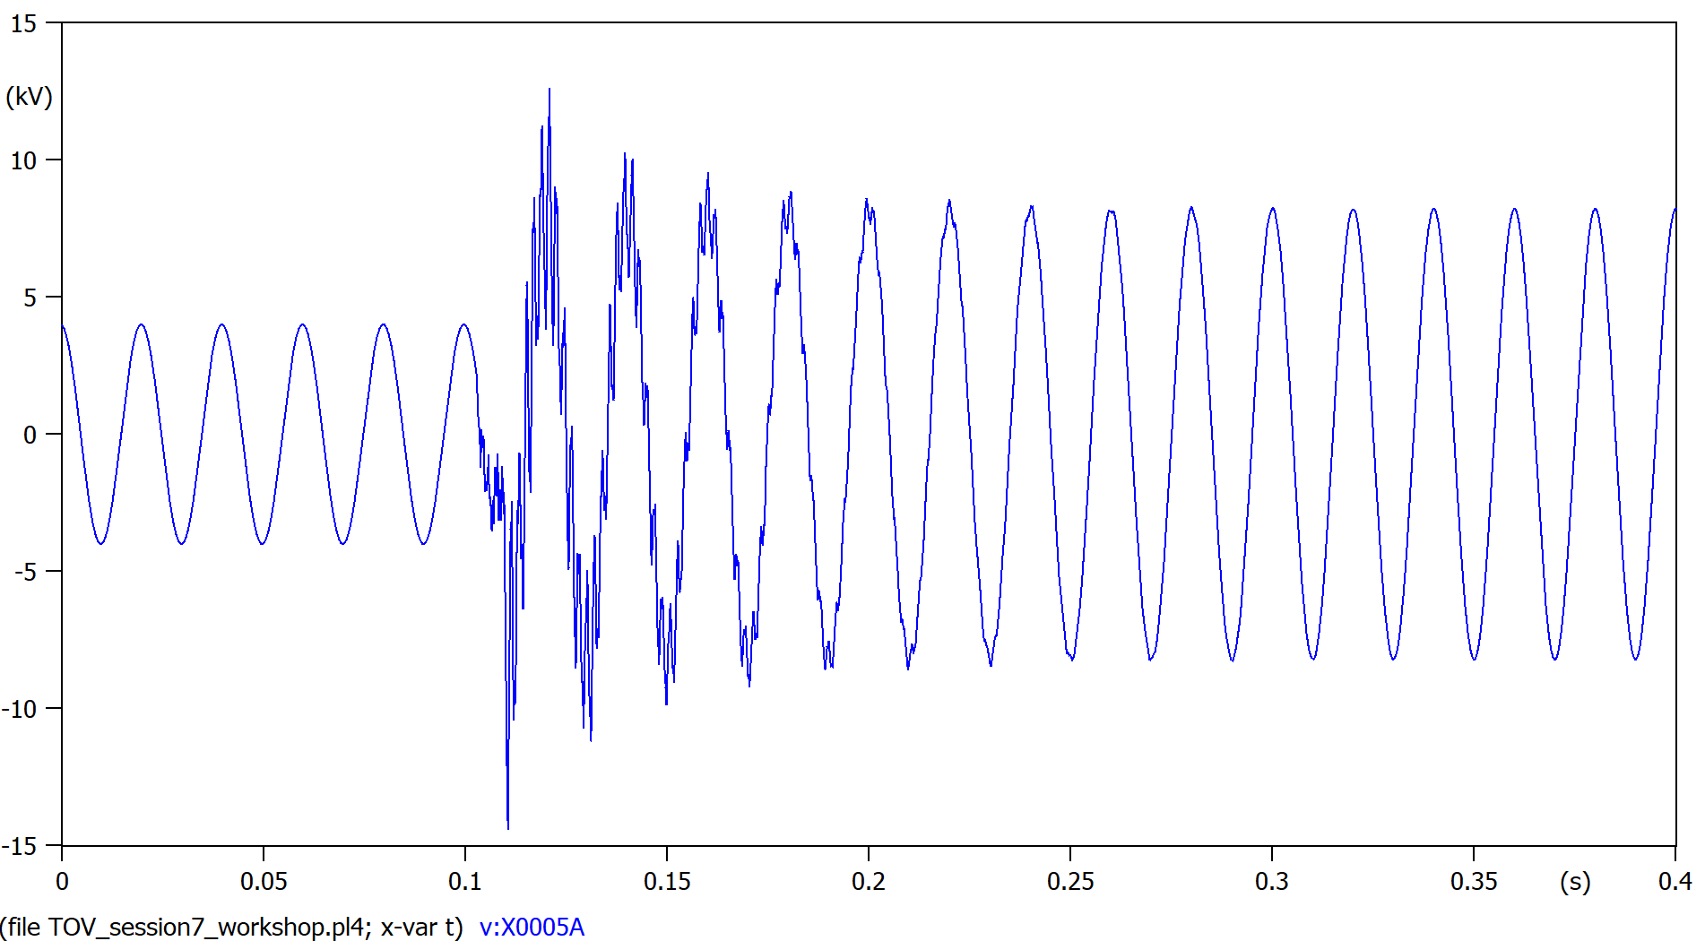

Figure 10, voltage of phase A in between transmission line and TOV switch.  
Lines are 50+50=100Km long

As expected, the current seen from the load abruptly stops. (Figure 11).  
But from the perspective of the generator, the current output lowers but doesn’t reach 0, this residual current is dissipated by the transmission lines themselves. (Figure 12)

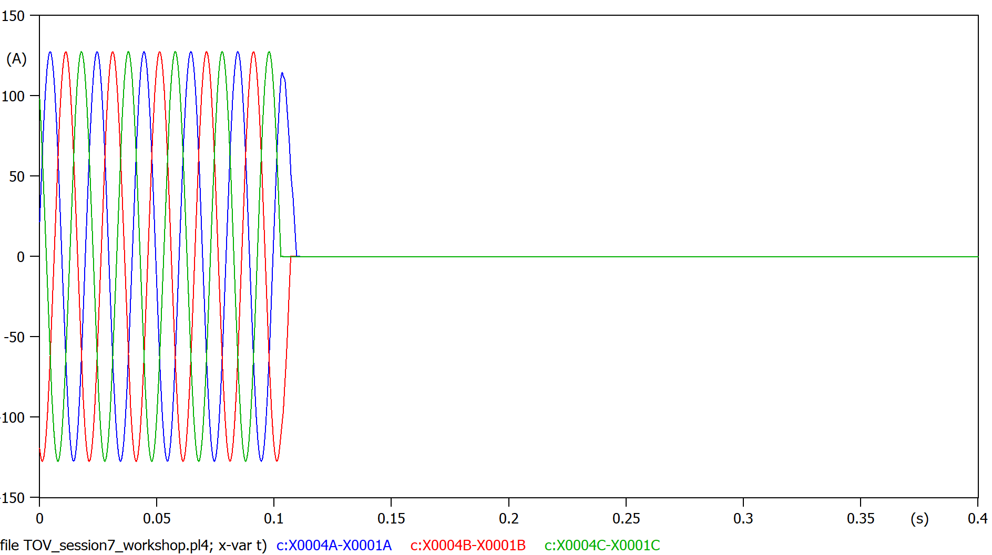

Figure 11, currents as seen by the load

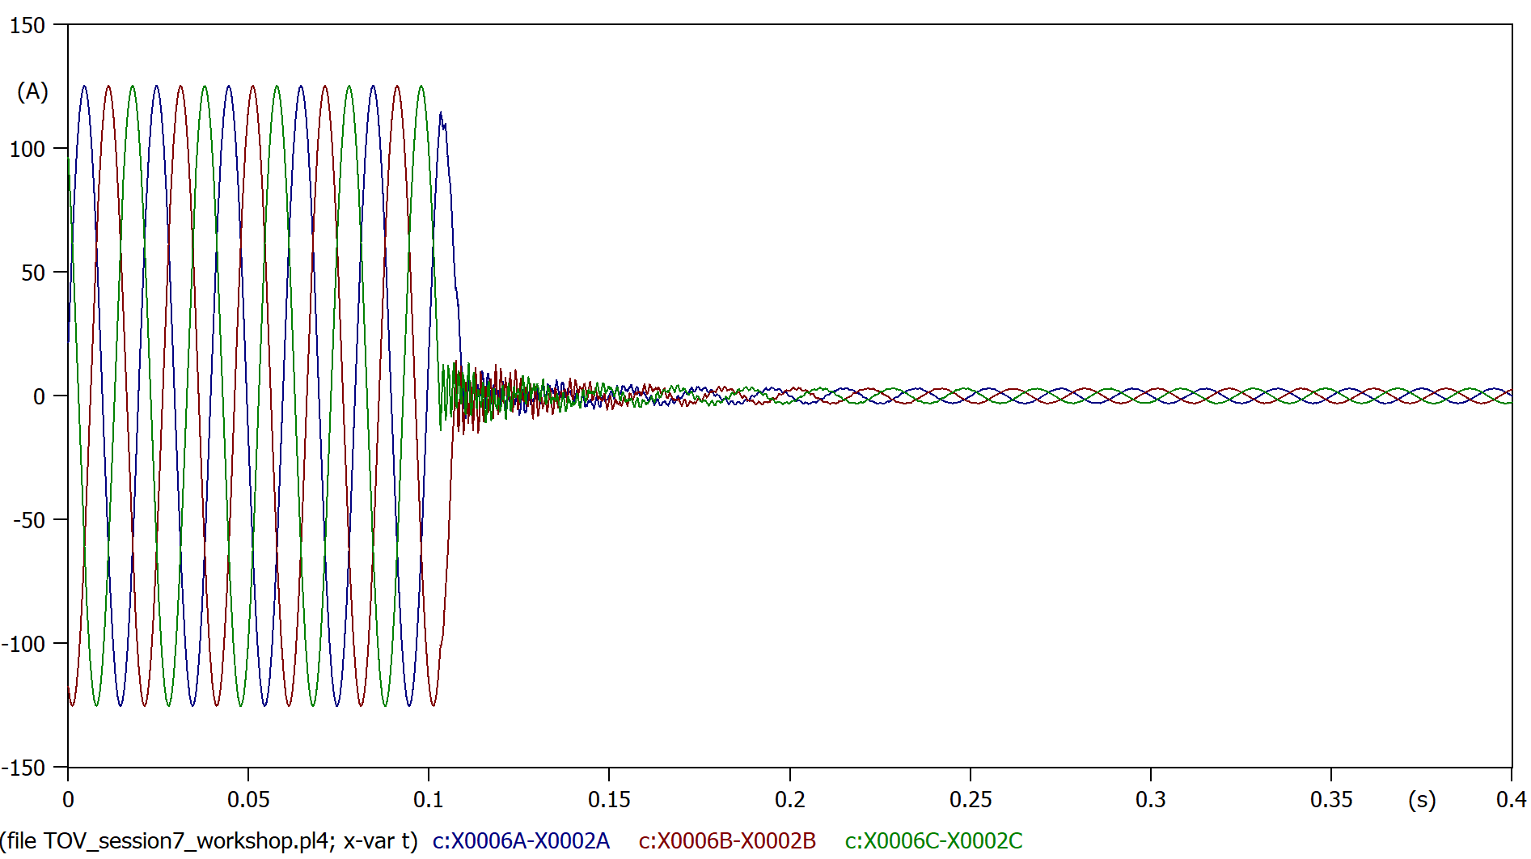

Figure 12, current as seen by the grid (generator)

Taking a look to Figure 13, focusing before the “Load rejection” happens (<0.1s), we see voltage drop happening in the transmission lines due to the current flow.  
Once the “load rejection” transitory settles, we notice there is almost no differences between all voltages, this is due to the much lower current flowing through the transmission line (Figure 12).

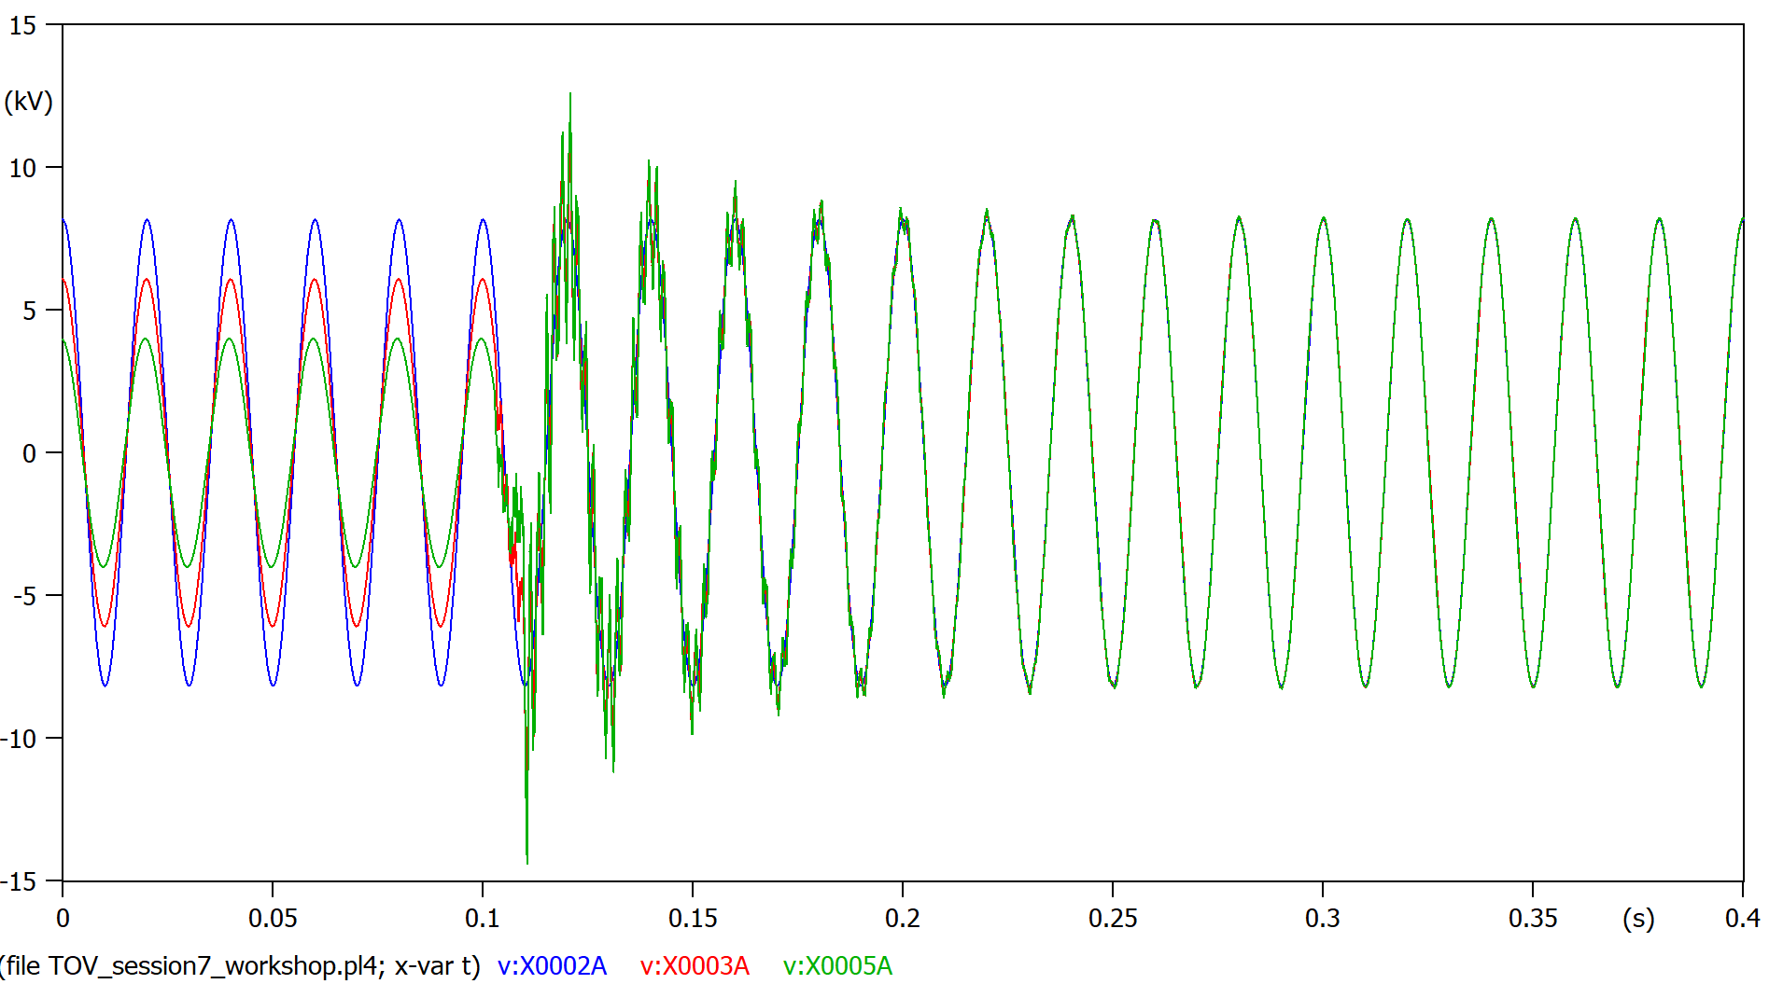+9

Figure 13, Single phase voltage from the grid (blue), in between transmission lines (red), at the load (green)